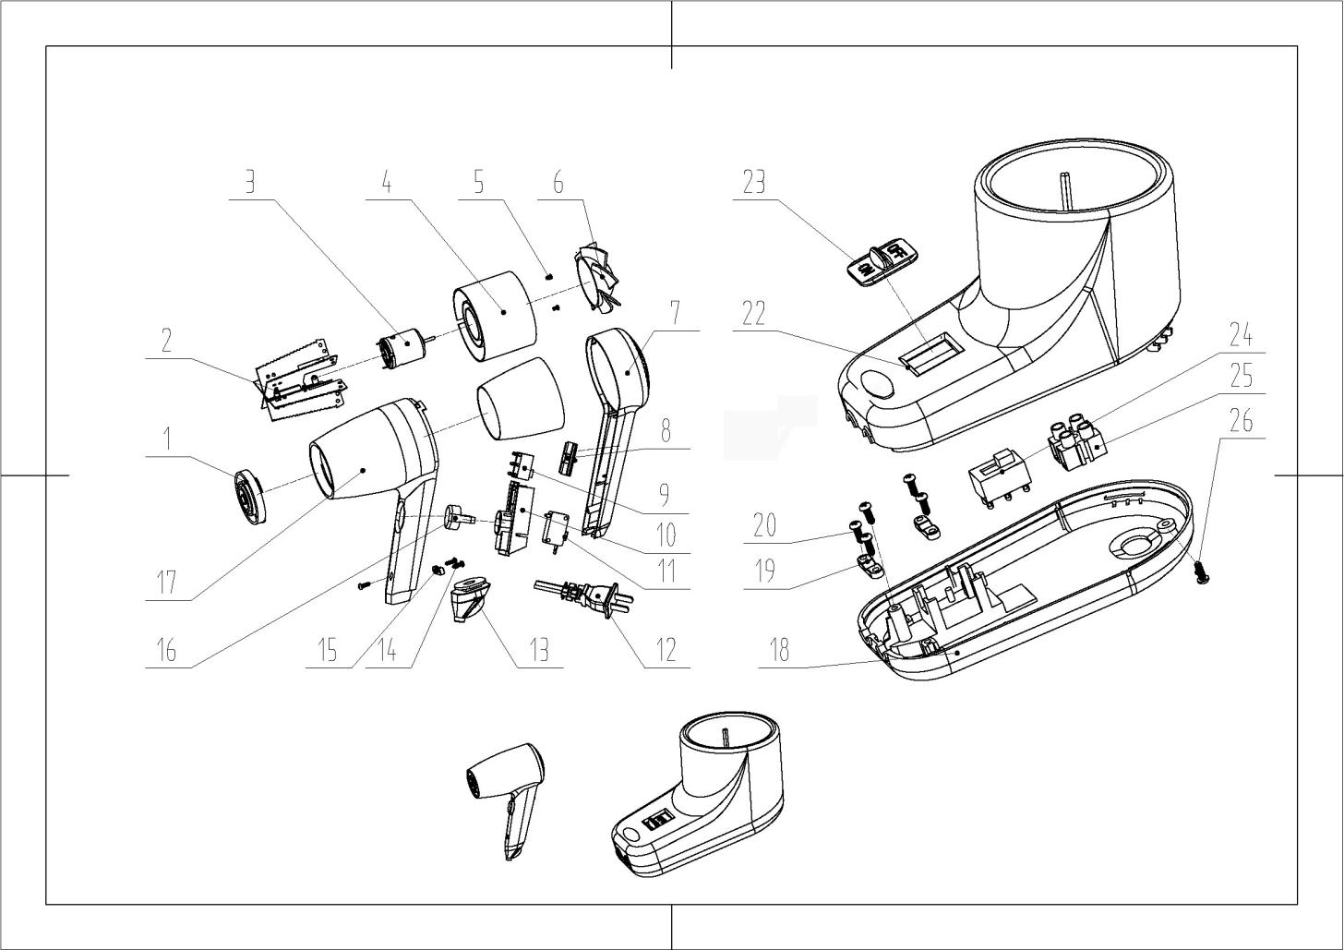

1 出风网 net for out wind
2热头 heating element
3 马达 motor
4 马达座 motor holder
5 螺丝 screws
6风叶 fan
7 后盖 hair dryer back cover
8 开关推板 switch board
9 档位开关 switch
10 开关座 switch holder
11 微动开关 Micro switch
12 插头 Plug
13 护线套 protecting cover
14 螺丝 screws
15 压线板 pressing plate
16 开关按钮switch button
17 机子前筒 front body
18.22 底座 holder
19 压线板 pressing plate
20 螺丝 screws
23开关推板 switch board
24 推板开关 switch
25 接线柱 connector
26 螺丝 screws

